PROBLEM STATEMENTS

|  |  |
| --- | --- |
| Date | 15 October 2022 |
| Domain Name | Internet Of Things (IoT) |
| Project Name | Smart Solution For Railways |
| Team ID | PNT2022TMID03711 |

**Example PS :1**

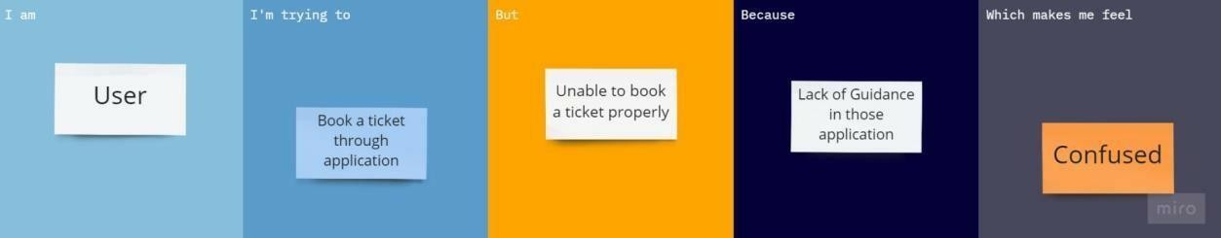

**PS :2**

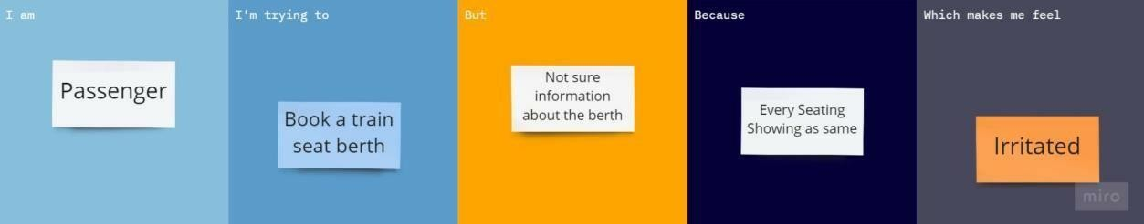

**PS :3**

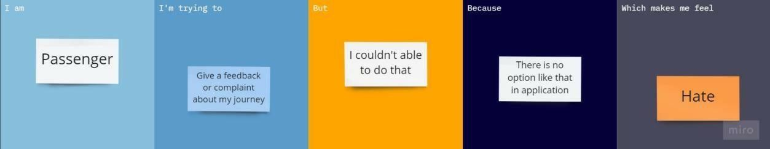

**PS :4**

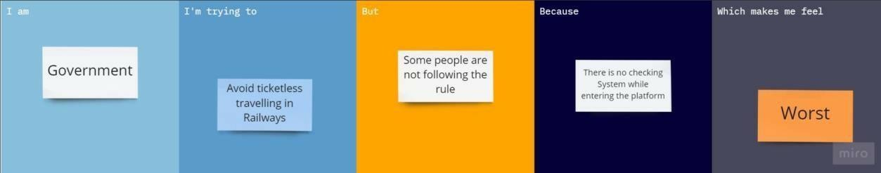

|  |  |  |  |  |  |
| --- | --- | --- | --- | --- | --- |
| **Problem Statement (PS)** | **I am (Customer)** | **I’m trying to** | **But** | **Because** | **Which makes me feel** |
| PS - 1 | User | Book a ticket through application | Unable to book ticket properly | Lack of Guidance in those application | Cofused |
| PS – 2 | Passenger | Book a train Seat Berth | Not Sure information about the berth | Evert seating showing as same | Irritated |
| PS – 3 | Passenger | Give a feedback or complaint about my journey | I couldn’t able to do that | There is no option like that in application | Hate |
| PS – 4 | Government | Avoid Ticketless traveling in Railways | Some people are not following the rule | There is no checking while entering the platform | Worst |